SME BUSINESS CONTINUITY TOOLKIT

Practical Business Continuity Handbook
Short guidance for small and medium-sized organisations
Resilience means understanding what matters most and being ready to adapt when something goes wrong.

Important: This toolkit provides general business continuity guidance. Each organisation remains responsible for its own legal, regulatory, contractual, insurance, information security, health and safety and sector-specific requirements. Completion does not guarantee continuity, plan approval, incident response support or operational support. Emergency services and life-safety instructions take priority.

1. Why prepare?
Disruption may result from severe weather, flooding, fire, cyber incidents, loss of staff, technology or telecommunications failure, utility outage, transport disruption, supplier failure, loss of access to premises or sudden financial and commercial pressures. Planning ahead helps an organisation protect people, focus limited resources, communicate clearly and recover priority activities in a controlled way.

2. Keep the approach proportionate
- Concentrate on priority products, services and activities.
- Avoid duplicating information that is controlled elsewhere.
- Record realistic alternatives, not idealised arrangements.
- Keep essential contacts and instructions securely accessible away from the normal workplace and IT.
- Make documents short enough to use under pressure.

3. The continuity cycle
Stage | Practical outcome
Understand | Identify priority activities, impacts, dependencies and recovery needs.
Plan | Record activation, decision-makers, contacts, actions, alternatives and communications.
Prepare | Reduce avoidable weaknesses and ensure people know their roles.
Respond | Protect people, assess impacts, set priorities, act and communicate.
Recover | Restore priority activities, monitor temporary arrangements and return safely.
Learn | Record lessons, assign actions and update arrangements.

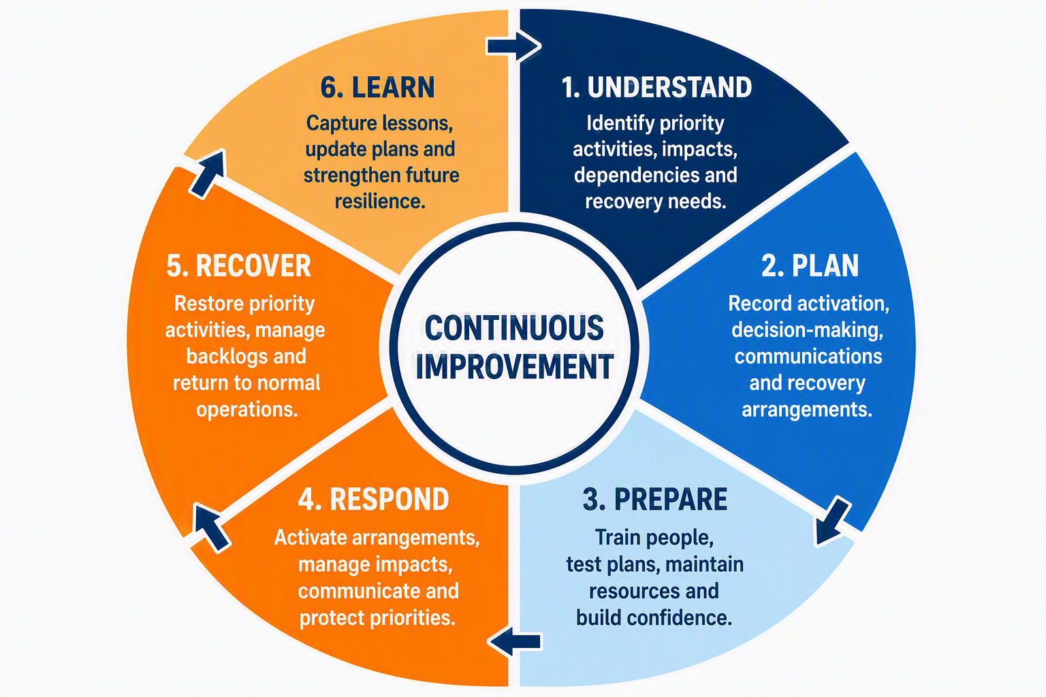

4. Key terms
Term | Plain-English meaning
Priority activity | An activity that must continue or be restored before less important work.
Maximum Tolerable Period of Disruption (MTPD) | The point after which the impact of not carrying out the activity would become unacceptable.
Recovery Time Objective (RTO) | The target time for restoring the activity to an agreed minimum level. It should normally be shorter than the MTPD.
Minimum service level | The reduced but acceptable level of delivery during disruption.
Dependency | A person, site, system, supplier, utility, item of equipment or information needed for delivery.
Workaround | A practical temporary way of continuing or restoring an activity.

5. Questions for each priority activity
- What must still be delivered in the first few hours, first day and following days?
- When would the impact become unacceptable?
- What is the minimum acceptable service?
- What people, skills, premises, technology, information, utilities and suppliers are essential?
- Where are the single points of failure?
- What can be done manually, remotely, elsewhere or at a reduced level?
- Who decides, who acts and who must be informed?

6. Indicative impact rating
Use impact ratings to support discussion and prioritisation. Consider the highest consequence alongside how quickly the impact develops, safety and legal duties, dependencies and the organisation’s risk appetite.
Rating | Guide
Green - Low | Minor disruption; small adjustments or short delays are normally sufficient.
Amber - Medium | Noticeable disruption; workarounds and prioritised recovery action are needed.
Red - High | Major service reduction or significant customer, financial, legal or reputational impact.
Black - Severe | Critical failure, serious safety or legal consequences, or sustained inability to operate.

7. Typical continuity options
- Remote or alternative-location working.
- Reduced services, opening hours or appointment-only arrangements.
- Cross-trained staff, deputies or temporary redeployment.
- Manual forms, offline records and alternative trusted communications.
- Alternative suppliers, mutual aid or substitute materials.
- Prioritised restoration of critical systems and data from tested backups.

8. Cyber and information disruption
- Plan for loss of systems, cloud access, email or telecommunications.
- Consider compromised accounts and information that may be unavailable or untrusted.
- Record an alternative trusted communication route.
- Know how to contact contracted IT or cyber support.
- Test restoration of important data and refer technical response to the organisation’s cyber incident plan.

9. Sectors and special requirements
Generic templates cannot replace sector-specific arrangements. Confirm requirements affecting care and safeguarding, food safety, health services, financial services, utilities, education or childcare, hazardous materials, transport, commissioned public services, data protection and cyber security.

10. Exercise and improve
At least annually, carry out a proportionate check such as a contact test, backup restore, supplier check, discussion exercise, scenario walkthrough or practical test of a workaround. Record actions, owners and target dates and update the documents after significant change, disruption, a near miss or an exercise.

11. Going beyond business continuity
The Business Resilience Companion Toolkit can be used to explore wider financial, commercial, workforce, strategic and leadership issues that may affect the organisation’s long-term ability to adapt and remain viable. It is an optional companion to, rather than a replacement for, the Business Impact Assessment, Business Continuity Plan and implementation checklist.

